1.
#include <stdio.h>
#include <string.h>
#include <ctype.h>
int main() {
char text[100];
int key, i;
printf("Enter plaintext: ");
fgets(text, sizeof(text), stdin);
printf("Enter key (1-25): ");
scanf("%d", &key);
printf("Cipher Text: ");
for(i = 0; text[i] != '\0'; i++) {
char ch = text[i];
if(isupper(ch))
printf("%c", ((ch-'A'+key)%26)+'A');
else if(islower(ch))
printf("%c", ((ch-'a'+key)%26)+'a');
else
printf("%c", ch);
}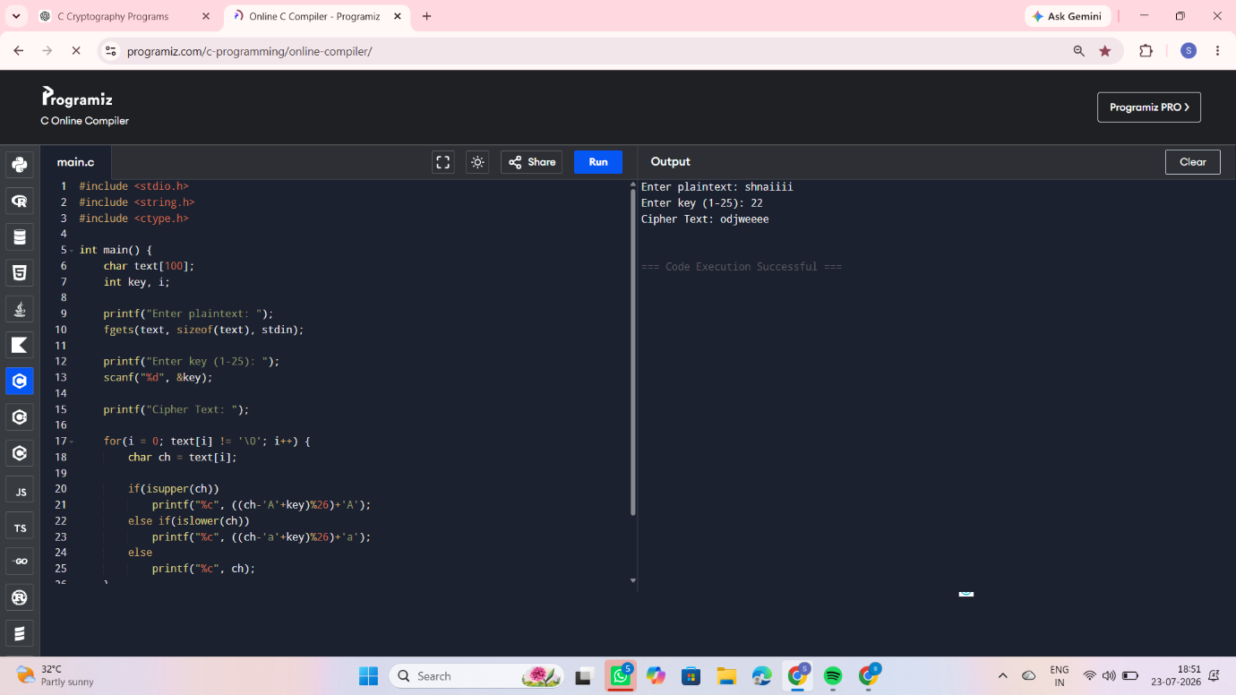
return 0;
}
2.
#include <stdio.h>
#include <ctype.h>
#include <string.h>
int main() {
char plain[100];
char key[] = "QWERTYUIOPASDFGHJKLZXCVBNM";
int i;
printf("Enter Plain Text: ");
fgets(plain, sizeof(plain), stdin);
printf("Cipher Text: ");
for(i=0; plain[i]!='\0'; i++) {
char ch = plain[i];

if(isupper(ch))
printf("%c", key[ch-'A']);
else if(islower(ch))
printf("%c", tolower(key[ch-'a']));
else
printf("%c", ch);
}
return 0;
}
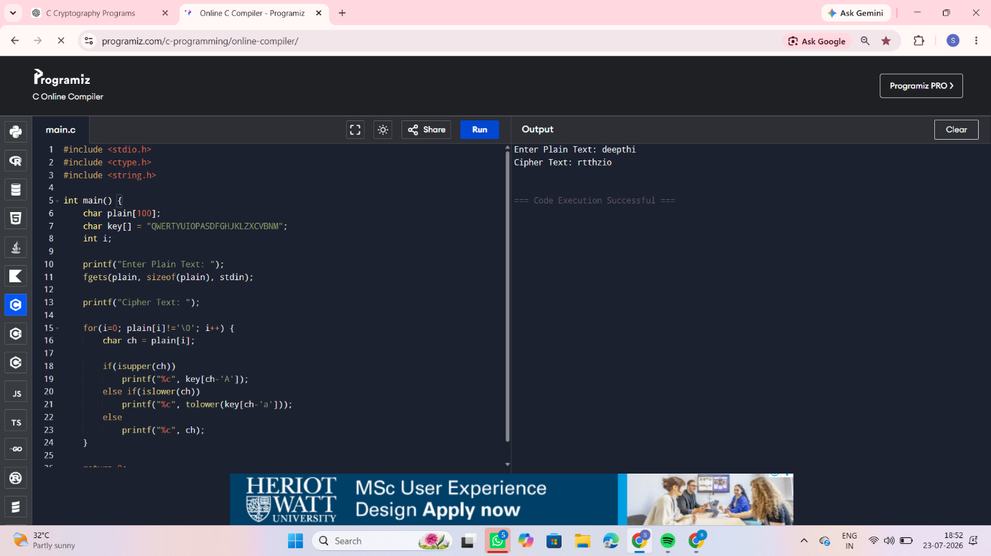
3.
#include<stdio.h>
#include<string.h>
#include<ctype.h>
char matrix[5][5] = {
{'M','O','N','A','R'},
{'C','H','Y','B','D'},
{'E','F','G','I','K'},
{'L','P','Q','S','T'},
{'U','V','W','X','Z'}
};
void find(char c,int *r,int *col)
{
if(c=='J')
c='I';
for(int i=0;i<5;i++)
for(int j=0;j<5;j++)
if(matrix[i][j]==c)
{
*r=i;
*col=j;
}
}
int main()
{
char text[100];
printf("Enter Plain Text (Even letters): ");
scanf("%s",text);
printf("Cipher Text: ");
for(int i=0;text[i]!='\0';i+=2)
{
int r1,c1,r2,c2;
find(toupper(text[i]),&r1,&c1);
find(toupper(text[i+1]),&r2,&c2);
if(r1==r2)
{
printf("%c%c",matrix[r1][(c1+1)%5],matrix[r2][(c2+1)%5]);
}
else if(c1==c2)
{
printf("%c%c",matrix[(r1+1)%5][c1],matrix[(r2+1)%5][c2]);
}
else
{
printf("%c%c",matrix[r1][c2],matrix[r2][c1]);
}
}
return 0;
}
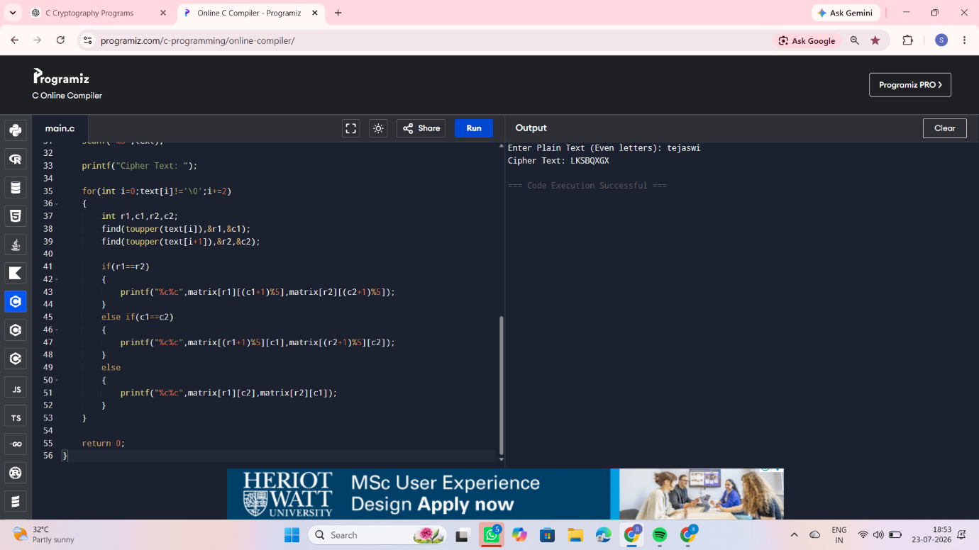
4.
#include<stdio.h>
#include<string.h>
#include<ctype.h>

int main()
{
char text[100],key[100];
int i,j;

printf("Enter Plain Text: ");
scanf("%s",text);

printf("Enter Key: ");
scanf("%s",key);

printf("Cipher Text: ");

for(i=0,j=0;text[i]!='\0';i++)
{
char ch=toupper(text[i]);
char k=toupper(key[j]);

printf("%c",((ch-'A'+k-'A')%26)+'A');

j=(j+1)%strlen(key);
}

return 0;
}
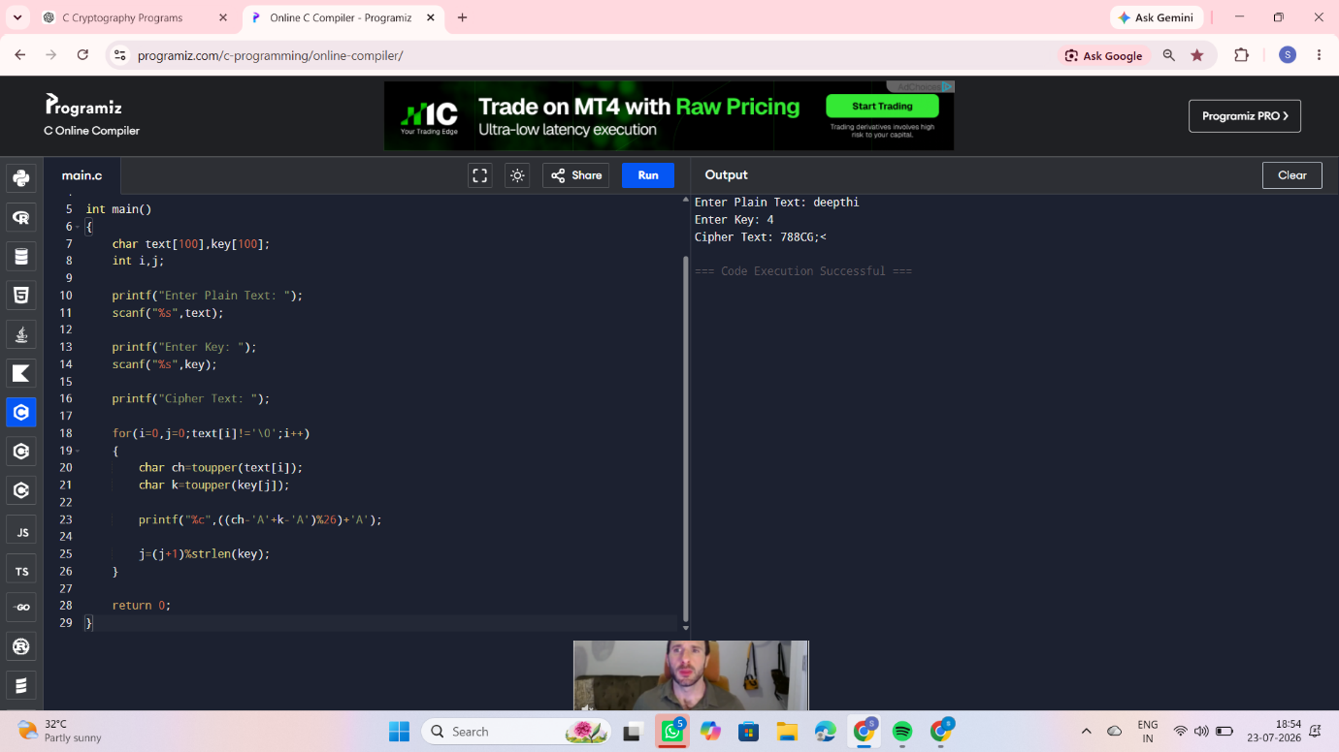
5.
#include<stdio.h>
#include<ctype.h>

int main()
{
char text[100];
int a,b,i;

printf("Enter Plain Text: ");
scanf("%s",text);

printf("Enter value of a: ");
scanf("%d",&a);

printf("Enter value of b: ");
scanf("%d",&b);
printf("Cipher Text: ");
for(i=0;text[i]!='\0';i++)
{
char ch=toupper(text[i]);
if(isalpha(ch))
{
int p=ch-'A';
int c=(a*p+b)%26;
printf("%c",c+'A');
}
}
return 0;
}
